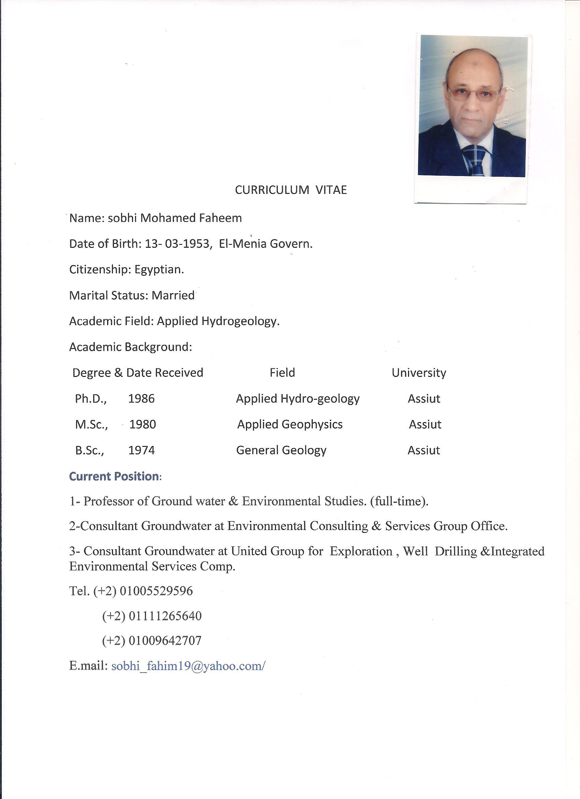

Work Experience:
A-Hydro-Geophysical Survey Projects
1- Red Sea Governorate:
*-Hurghada City:
1-Hilton El-Nour Resort.
2-Royal Azur Resort.
3-Meridian Resort.
4-Domina Resort.
5-Seriniti Resort
6-Cleopatra Luxury Resort.
7-Grand Plaza Resort.
8-Desert Rose Resort.
9-Blumar Resort.
10-Wadi El-Rada.
*-Hurghada-Safaga Road:
Caribian World Resort
*-Al-Quseir City:
1-Flaminco Resort.
2-Yotobia Resort.
3-Shagra Diving Center.

4-Movenbic Resort.
5-Sarina Beach Resort.
6-Grand Resta Resort. (k-65 south Quseir).
7-Reef Resta Resort. (K-67 south Quseir).
8-Egypt Mark Resort.
9-Cleopatra Resort Project (K-40 south Quseir).
10-Wadi El-Nakheel.
*-Marsa Alam City:
1-Shams Alam Resort.
2-Rotec Desalination Plant.
3-Blue Bird Resort.
4-Econiks Resort.
5-Al-Masreen Desalination Plant (k-30 South Marsa Alam).
6-Baranis Wadi Lahmy.
*-El-Shalatin Area:
1-Abraq village.
2-El-gahelia village.
3-Adaldeeb village.
4-Abu Ghoson.

*-Ras Gharib:
-Dolphin Farm.
*-Ain El-Sokhna area:
1-Shatt Al-Nakhil Resort.
2-Marina Wadi Degla Resort.
3-Blumar El-Dom Resort.
4-Blumar Dor Kas Resort.
5-Piacera Resort.
6-La Vesta 6 Resort.
7-Ocean Blue Resort.
8-Lalona Beach Resort.
2-North Sinai Governorate:
-Al-Areesh City:
Cement Factory.

3-South Sinai Governorate:
*-Ras Sudr City:
1-Bent Al-Soltan Resort.
2-Blue Bay Resort.
3-Manta Farm.
4-Paradise Resort.
5-Palm Beach Resort.

*-Sharm El-Sheikh City:
1-Fantazia Nema Bay Resort.
2-Retz Carleton Resort.
3-Aqabolco Resort.
4-Grand Azur Resort. (Nabq area).
5-Helnan Resort. (Nabq area).
6-Hilton waterfalls Resort.
7-Hilton El-Fayrouz Resort.
8-Reef Oasis.
9-King Snephro Resort.
10-Sonesta Beach Resort.
11-Meridian Resort.
12-Rehana Resort.
13-Daimond Plaza Resort.
14-Coral Sea Resort.
15-Nubia Sharm Resort.
16-Al-Nubbia Village.
17-Germeny School.
18-Cleopatra Luxry Sharm Resort.

19-Dream Sharm Resort.
20-Al Dahabia Desalination Plant.
*-Dahab City:
1-Hilton Dahab Resort.
2-Mercure Bay View Resort.
3-Happy Life Resort.
4-Canyon Resort.
5-Swiss Inn Resort.
*-Neweiba City:
1-Coral Hilton Resort.
2-Al-Salam Resort.
3-Dolphin Resort.
*-Taba City:
1-Movenbic Resort.
2-Sheraton Resort.
4-Port Said Governorate:
- Desalination Plant For Saqr Factory.
5-Giza Governorate:
1-Quick Cargo (Abu Rawash Area).

2-Four Season Resort.
3-Movenbic 6-October city.
4-Sheraton Dream 6-October City.
6-Cairo Governorate:
1-Cairo- Ismailia Desert Road.
2-Manterak Area.
10th Ramadan City:
-Arab Brothers Factory.
7-Helwan Governorate
-Behman Hospital.
8-Cairo-Alex Desert Road
1-Nahl Bottling Water Factory.
2-Al-Abd Desert Village.
9-Northern Western Coast
1-Ghazala Bay Village.
2-Marina Wadi Degla Resort.
3-Amwaj Resort.
4-Hacienda Resort.
5-La Vesta Resort.

6-Marina Gardens Resort.
7-SeaShell Project.
8-Lagoon Project.
9-Zone Project.
10-City Star Project.
11-Playa Project.
12-Porto Golf Marina.
10-Marsa Matrouh Governorate:
1- Samala Resort.
2-Cleopatra Resort.
3-Al-Abd Resort.
4-Almaza Project.
4-Andalusia Resort.
11-El-Menia Governorate
1-Shousha Area.
12-Souhag Governorate
1-Souhag new University.
2-Al-Kawthar Village.
13-Qena Governorate
-Al-Nour Company.
14-Alexandria Governorate:
-Crush Factory for Soft Drink.
-Alex West Project.

B)-Supervision of Drilling Wells
1-Red Sea Governorate
Project | No. of Wells | Type of wells | Location
Royal Azur Resort | 7 | Feed | Hurghada
Meridian Resort | 1 | Feed | Hurghada
Domina Resort | 3 | Feed | Hurghada
Sereniti Resort | 8 | 4 feed & 4 Reject | Hurghada
Fantazia Resort | 6 | 3 Feed & 3 Reject | Hurghada
Caribian World | 7 | Reject | Hurghada
Desert Rose Resort | 3 | Feed | Hurghada
Banorama Resort | 2 | Feed | Hurghada
Flamenco Resort | 3 | Feed | Quseir
Sarina Beach Resort | 1 | Feed | Quseir
Shagra Diving center | 2 | Feed | Quseir-Marsa Alam Road
Shams Alam Resort | 2 | Feed | Marsa Alam
Ferroland Resort | 5 | 3 Feed & 2 Reject | South Marsa Alam.
Grand Resta Resort | 12 | 7 Feed & 5 Reject | South Quseir
Dolphin Farm | 1 | Feed | Ras Gharib
Al Dorado Resort | 6 | 3 Feed & 3 Reject | South Quseir
Marina Wadi Degla  Blumar El Dom  Blumar Dor Cas  La Lona Resort  Piacera Project  La Vesta Project  El-Ain Bay Resort  Blue Ocean Resort | 4  4  4  3  1  2  3  2 | 2 Feed & 2 Reject | Ain El-Sokhna  Ain El-Sokhna  Ain El-Sokhna  Ain El-Sokhna  Ain El-Sokhna  Ain El-Sokhna  Ain El-Sokhna  Ain El-Sokhna
Horse Desalination Plant | 4 | Feed | Marsa Alam
Quseir Desalination Plant | 6 | Feed | Quseir
Soma Bay Resort | 7 | (1) Feed &( 6) Reject | Hurghada

2-South Sainai Governorate
Bent Al-Soltan | 3 | Feed | Ras Sudr
Manta Farm | 1 | Feed | Ras Sudr
Palm Beach Resort | 3 | 2 Feed & one Reject | Ras Sudr
Paradise Resort | 3 | Feed | Ras Sudr
Fantazia Resort | 4 | 2 Feed & 2 Reject | Sharm El-Sheikh
Retz Carleton Resort | 6 | 2 Feed & 4 Reject | Sharm El-Sheikh
Grand Sharm Resort | 5 | 3 Feed & 2 Reject | Sharm El-Sheikh
Grand Azur Resoprt | 3 | 2 Feed & one Reject | Sharm El-Sheikh
Hilton Al-Fayrouz | 3 | Feed | Sharm El-Sheikh
Hilton Waterfalls Resort | 6 | 4 Feed & 2 Reject | Sharm El-Sheikh
Hilton Dreams Sharm | 2 | Feed | Sharm El-Sheikh
King Snefro | 2 | Feed | Sharm El-Sheikh
Sonesta Beach Resort | 1 | Feed | Sharm El-Sheikh
Meridian Resort | 4 | 2 Feed & 2 Reject | Sharm El-Sheikh
Hauza Resort | 1 | Feed | Sharm El-Sheikh
Happy life Resort | 1 | Feed | Dahab
Hilton Dahab Resort | 3 | Feed | Dahab
Mercure Bay View | 4 | 2 Feed & 2 Reject | Dahab
Dolphin Resort | 1 | Feed | Neweiba
El-Salam Village | 4 | 2 Feed & 2 Reject | Sharm El-Sheikh
Coral Hilton Neweiba Resort | 4 | 2 Feed & 2 Reject | Neweiba
Morgana Taba Resort | 1 | Reject | Taba
Swiss Inn Resort | 1 | Reject | Dahab
Calemira Resort | 5 | 3 Feed & 2 Reject | Sharm El-Sheikh
Rehana Resort | 5 | 3 Feed & 2 Reject | Sharm El-Sheikh

Nubia Sharm Resort | 2 | Reject | Sharm
Coral Sea Resort | 5 | 3 Feed & 2 Reject | Sharm
Sansatory Sharm | 60 | 45 Feed & 15 Reject | Sharm
Cleopatra Luxry Resort | 4 | 2 Feed & 2 Reject | Sharm
Cress Resort | 3 | 2 Feed & one Reject | Sharm
Diamond Plaza | 7 | 4 Feed & 3 Reject | Sharm
Metito Desalination Plant | 6 | Feed | Sharm
Dream Sharm Resort | 2 | Feed | Sharm

3-Port Said Governorate
Project | No. of Wells | Type of wells | Location
Desalination Plant Of Saqr Factory | 3 | 2 Feed & one Reject | East Port Said

4-10th Ramadan City
Project | No. of Wells | Type of wells | Location
Desalination Plant at Arab Brothers Comp. | 1 | Feed | 10th Ramadan

5-Cairo – Alex Road
Project | No. of Wells | Type of wells | Location
Villa Eng. M. Nosair | 1 | Reject | Cairo-Alex Road
Nahl Bottling water factory | 1 | Feed | Al- Sadat City
Four Season Resort | 2 | Feed & Reject | Azizia

6-Gharbia Governorate
Project | No. of Wells | Type of wells | Location
Organic Factory | 1 | Feed | New Nobaria
Kafr El-Zayat | 1 | Feed | New Nobaria

7-Northern Coast
Project | No. of Wells | Type of wells | Location
Marina Wadi Degla | 4 | 2 Feed & 2 Reject | Sidi Abdel- Rahman
Maraci Project | 8 | Feed | Sidi Abdel Rahman
La Vesta Project  Amwaj Resort  Sea Shell Resort  Lagoon Project  Hacienda Resort  Porto Golf Marina  Almaza Resort | 4  35  30  8  2  7  4 | 2 Feed & 2 Reject  17 Feed & 18 Reject  13 Feed & 3 Reject  4 Feed & 4 Reject | Dabaa area  Sidi Abdel Rahman  Sidi Abdel Rahman  Al Alamen

8-Marsa Matrouh Governorate
Project | No. of Wells | Type of wells | Location
Andalusia Village | 3 | Feed | Alam El-Roum
Samala Resort | 4 | 2 Feed & 2 Reject | Alam El-Roum
Cleopatra Resort | 4 | 2 Feed & 2 Reject | Almaza
Al Abd Village | 3 | 2 Feed & one Reject | Sidi Henaish

9-Souhag Governorate
Project | No. of Wells | Type of wells | Location
Souhag University | 4 | Feed | Al- Kawamel
Al-Kawthar Village | 3 | Feed | East Souhag City

C-Supervision of Periodic Maintenance of wells
Client | Location
Hilton waterfalls Resort | Sharm El-Sheikh
Hilton Al-Fayrouz Resort | Sharm
Hilton Dreams | Sharm
Cleopark Sharm | Sharm
Amphorus Holiday Resort | Sharm
Calemera Resort | Sharm
Grand Sharm Resort | Sharm
Mexicana Resort | Sharm
Grand Hotel | Sharm
Stella de Marie | Sharm
Cleopatra Resort | Sharm
Dream Sharm Resort | Sharm
Coral Sea Holiday Inn Resort | Sharm
Cress Village | Sharm
Sun Terra Village | Sharm
Desalination Plant of International Utilities Comp. | Sharm
Metito Desalination Plant | Sharm
Hilton Resort | Dahab
Mercure Bay View | Dahab
Morgana Resort | Taba
Royal Azur | Hurghada
Seriniti Resort | Hurghada
Fantazia Beach Resort | Hurghada
Desert Rose Resort | Hurghada
Banorama Resort | Hurghada
Caribian World Resort | Safaga
Soma Bay Resort | Safaga
Gorgonia Beach Resort | Marsa Alam

Grand Resta | Marsa Alam Road
Desalination plant of Arab Contractors | Marsa Alam
Rotec Desalination Plant | Marsa Alam
Cleopatra Project | Safaga-Quseir Road

D- Hydro-geological &Environmental Studies
1-Hilton waterfalls Resort- Sharm El-Sheikh.
2-Hilton El-Fayrouz - Sharm El-Sheikh.
3-Hilton Dreams -Sharm El-Sheikh.
4-Hilton Coral Neweiba -Neweiba City.
5-Amphorous Holiday Inn -Sharm……..
6-Stella De Marie- Sharm……..
7-Dream Sharm Resort- Sharm……...
8-Coral Sea Holiday Village- Sharm……...
8-Sheraton Resort.- Taba,
9-Sheraton Dream- 6 October Governorate.
10-Grand Resta Resort - Marsa Alam.
11-Caribian World Resort- Hurghada-Safaga Road.
12-Sereniti Resort - Makadi Bay.
13-Arab Contractors Desalination plant (Marsa Alam).
14-Mexicana Resort -Sharm……….
15-Samala Alam Al-Roum Resort- Marsa Matrouh.
16-Al-Abd Village- Marsa Matrouh.
17-La Vesta Resort - Northern Coast.
18-Mountain View - Northern Coast.
19-Al-Abd Desert Village- Cairo- Alex Road.
20-Swiss Inn Resort -Dahab.
21-Terrana Aquapark Resort-Sharm.
22-SeaShell Project- North Western Coast.
23-Stella Resort- N.W. C.
24-Amwaj Resort- N. W.C.

25-Royal Beach Resort.- N.W. C.
26-Bangalos Resort- N. W. C.
27-Marina Wadi Degla- N. W. C.
28-Porto Golf Marina Resort- N.W. C.
29-Maraci Resort.- N.W. C.
30-Marcilia Beach 2 Resort.- N.W. C.
31-Marcilia Beach 4 Resort.- N.W. C.
32-Marcilia Alam El-Roum- N.W. C.
33-Hacienda Bay Resort- N.W. C.
34-Hacienda White Resort- N.W. C.
35-Hacienda Sidi Abdel-Rahman Resort.

